Lab 1. Understanding ARP poisoning.

Arp poisoning is also called ARP spoofing.

There is actually a command ‘arpspoof’

After looking into ‘man arpspoof’, I checked its synopsis.

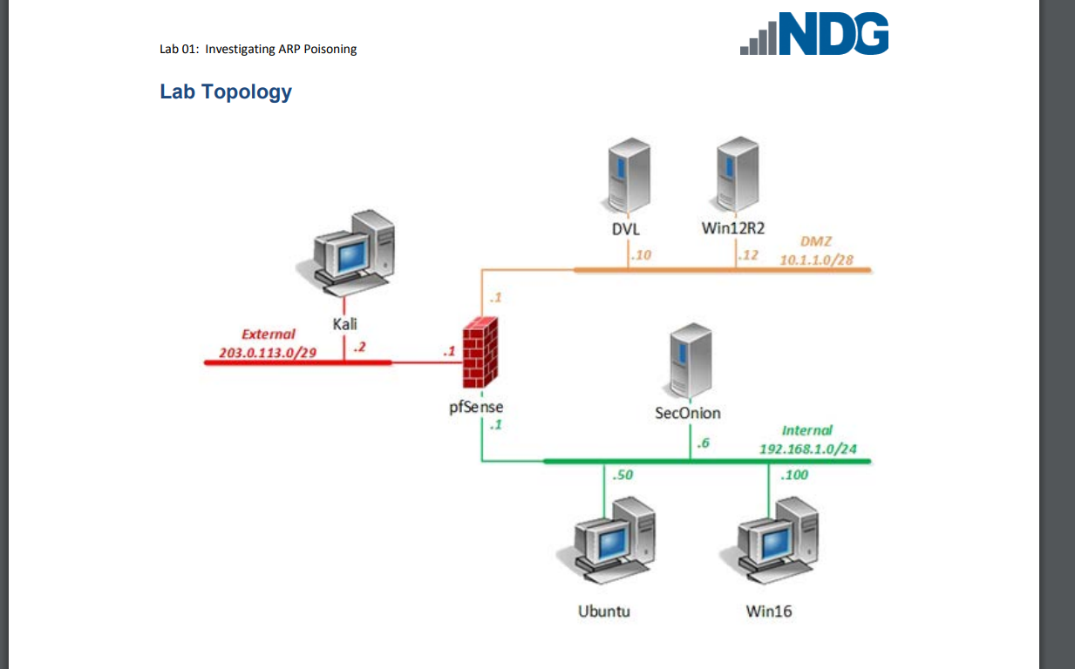

By typing ‘sudo arpspoof -i eth0 -t 192.168.1.1 192.168.1.100’ to set ubuntu’s ip address as 192.168.1.100.

By typing ‘sudo arpspoof -i eth0 -t 192.168.1.100 192.168.1.1’ to second terminal the ubuntu machine is now in between pfsense and win16.

Confirmed by pinging the pfsense from win16 machine and checked the ping packet arrive to ubuntu’s wireshark.

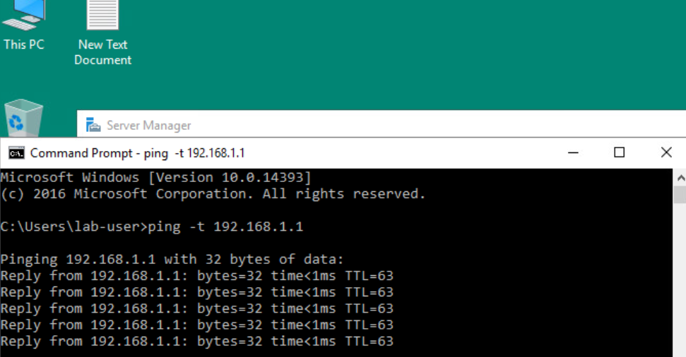

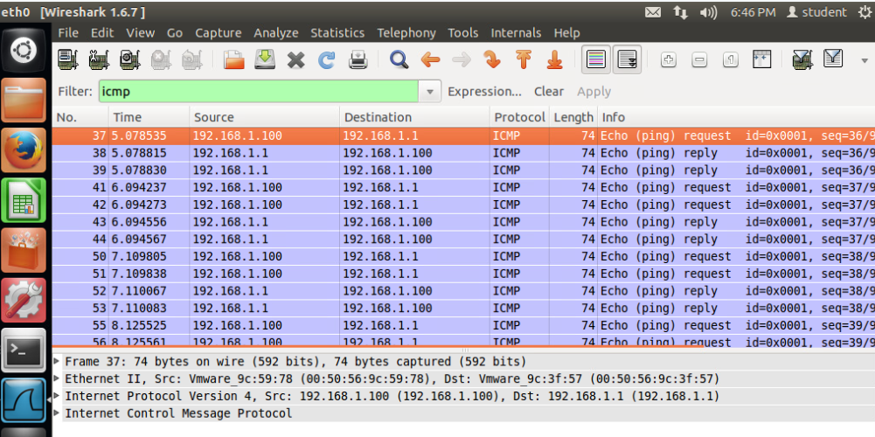

As you can see, ubuntu is receiving echo/ping request from 192.168.1.100 and the ubuntu machine is replying on behalf of pfSense.